


Media Release

EKA Mobility Partners with KPIT to Enhance Electric Powertrain Technology Components

Pune, India | 6th Feb 2025 | NSE: KPITTECH BSE: 542651

EKA Mobility, a leader in sustainable mobility solutions and KPIT Technologies, a global leader in building mobility technology solutions for a cleaner, smarter, and safer world, have entered into an MOU to develop and integrate cutting-edge electric powertrain technology components. This collaboration aims to set new benchmarks for efficiency, performance, and sustainability in India’s electric commercial vehicle (e-CV) industry.

The MoU will focus on developing advanced electric powertrain systems, such as Traction Motors, Controllers, Vehicle Control Units, and Battery Management Systems, tailored for EKA’s extensive range of electric buses and commercial vehicles. The MOU will leverage KPIT’s three decades of work in mobility and an extensive lineup of indigenously developed electric powertrain technologies. These innovations will enable EKA Mobility to deliver superior energy efficiency, reduced total cost of ownership (TCO), and an unmatched driving experience for its customers.

Speaking on the partnership, Dr. Sudhir Mehta, Founder & Chairman of EKA Mobility and Pinnacle Industries Limited, said, “We are delighted to partner with KPIT Technologies, a pioneer in mobility technology with over three decades of legacy. This collaboration underscores our commitment to redefining mobility by delivering cutting-edge, sustainable, and efficient electric vehicles to our customers. By leveraging KPIT’s expertise in electric powertrain technologies, we aim to accelerate India’s transition to zero-emission commercial vehicles."

“World over, consumers are looking for clean and safe mobility solutions that meet their everyday needs. KPIT’s electric powertrain solutions offer high efficiency and are highly cost competetive. We are pleased to collaborate with EKA, who are building a wide range of BHARAT-centric trucks, buses, and logistics fleet. Together, we will develop EV mobility solutions for country-specific use cases, promoting wide adoption,” said Mr. Kishor Patil, CEO, KPIT Technologies

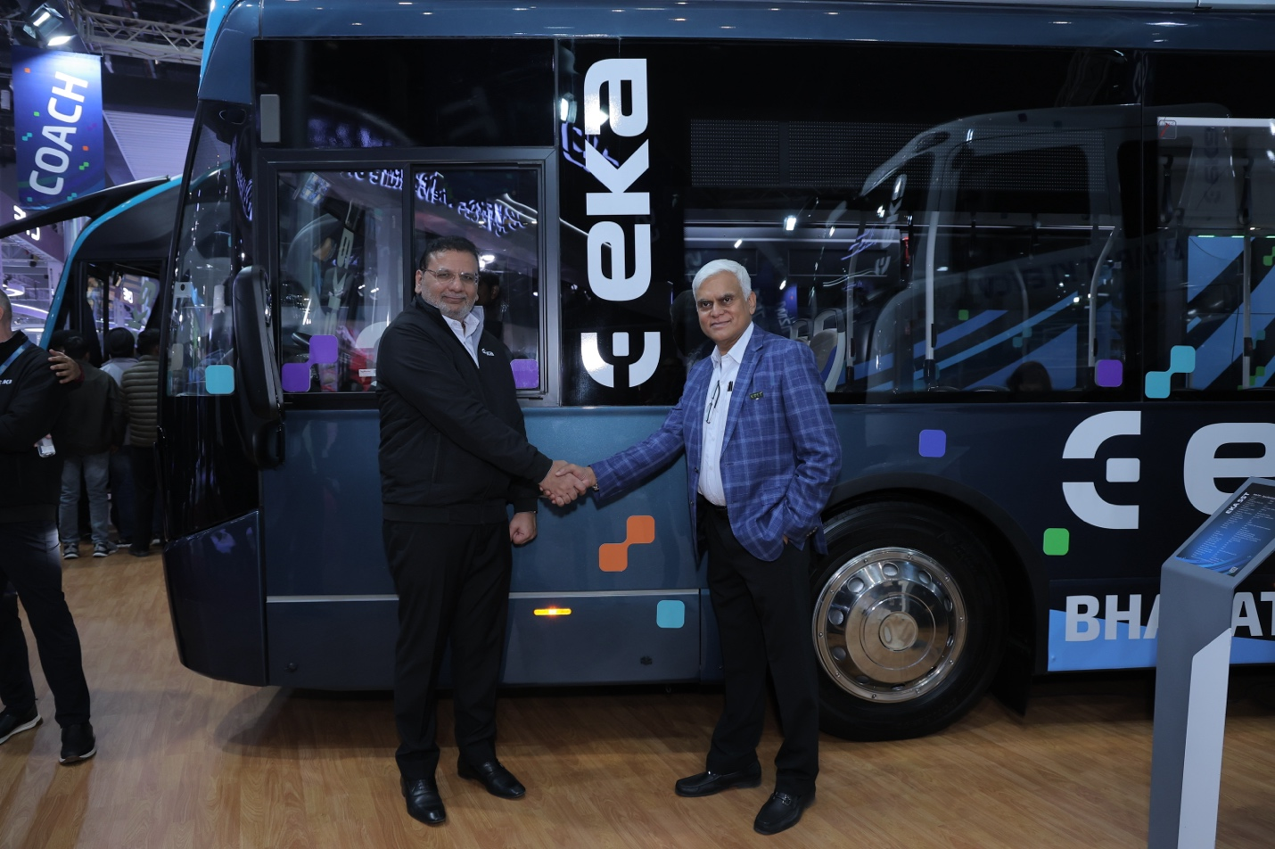
In Picture: Mr. Kishor Patil, CEO, KPIT Technologies with Dr. Sudhir Mehta, Chairman, Pinnacle Mobility at the Bharat Mobility Expo held in New Delhi , India between Jan 18-22, 2025

About EKA (Pinnacle Mobility Solutions Pvt. Ltd.):
EKA (Pinnacle Mobility Solutions Pvt. Ltd.), with Mitsui Co., Ltd. (Japan) & VDL Groep (Netherlands) as equity partners, is an automotive & technology company creating a new global CV electric mobility paradigm. EKA’s vision is to lead the world to a sustainable future by creating an ecosystem for Environment-Conscious Mobility. With an industry-leading team, cutting-edge technology, modular designs, and lean manufacturing processes, EKA’s mission is to bring reliable and efficient mobility solutions to the masses. EKA’s sharable technologies and low-investment production processes enable the lowest TCO and democratize electric vehicles for mass adaptation.
To know more about the company, kindly visit:
https://ekamobility.com
Media Contact
Harshita Singh, Head- Corporate Communications, PR & CSR
harshita.s@ekamobility.com | +91-70301-52828

About KPIT Technologies

KPIT Technologies is a global partner to the automotive and Mobility ecosystem for making software-defined vehicles a reality. It is a leading independent software development and integration partner helping mobility leapfrog towards a clean, smart, and safe future. With 13000+ automobelievers across the globe specializing in embedded software, AI, and digital solutions, KPIT accelerates its clients' implementation of next-generation technologies for the future mobility roadmap. With engineering centers in Europe, the USA, Japan, China, Thailand, and India, KPIT works with leaders in automotive and Mobility and is present where the ecosystem is transforming.

To know more, visit https://www.kpit.com/

KPIT Newsroom and Media resources center: https://www.kpit.com/newsroom/

MEDIA CONTACTS

Mohit Kochar
Global Head, Marketing | mohit.kochar@kpit.com

Sunil Ravish
Sr. Director, Marketing | Media Relations | sunil.r@kpit.com

INVESTOR RELATIONS
Sunil Phansalkar
Head, Investor Relations | sunil.phansalkar@kpit.com

